MEMORANDUM

TO: National Bar Association

FR: Erinn D. Martin, President
Greater Washington Area Chapter, Women Lawyers Division, National Bar Association (“GWAC”)

RE: 2020-2021 NBA Affiliate Chapter of the Year Award

DATE: June , 2021

GWAC’s 2020-2021 Bar Year: A Year of Exemplary Service

Since its inception in 1974, GWAC has contributed tireless efforts to uplifting and promoting the needs of the community, professionally developing its members, and connecting our community to those in need of legal support and services. As a dynamic organization, GWAC does not rest on its laurels; instead, we continually assess the current needs of our local legal community and plan our programming accordingly.

Since April 2017, GWAC has been on the forefront of advocacy, speaking out against unrest in Charlottesville, Virginia, supporting local non-profit organizations and the development of our youth. GWAC has worked to provide programming and social events that promote camaraderie and a much-needed sense of community within the circle of African-American female attorneys in D.C and to advance their professional development and careers. During the ongoing COVID-19 pandemic, we’ve pivoted to virtual programming to continue engaging with our members and the D.C. community.

We are proud of the work that GWAC has achieved within the past year, and we feel that it makes us particularly qualified for the National Bar Association’s Affiliate Chapter of the Year Award given our programming’s alignment with the NBA’s own noble mission. We appreciate your thoughtful consideration of GWAC’s candidacy for the NBA’s Affiliate Chapter of the Year Award.

Note: This memorandum highlights the notable activities and achievements of GWAC since April 2020, but it is not exhaustive of all of the work that we do. We encourage you to visit our website at gwacbar.org to learn more about the difference that GWAC is making in the District of Columbia metropolitan area’s legal community.

2020-2021 Calendar of Programs
2020

April 2020

4.18.20 – Your Place, Your Pace Virtual 5K

May 2020

5.9.20 – Virtual Kukuwa African Dance Workout
5.15.20 – DC Bar Candidates’ Forum
5.19.20 – Law Firm & Corporate Counsel Virtual Happy Hour
5.21.20 – Access to Reproductive Health Care: Being a Woman of Color During COVID-19
5.28.20 – GWAC Women’s Equity Series: Women of Color and COVID-19

June 2020

6.29.20 – Annual GWAC Installation Ceremony
6.30.20 – Virtual Toast to the Class of 2020

July 2020

7.16.20 – Where are the Black Women Lawyers in Leadership?

August 2020

8.8.20 – GWAC Board Retreat
8.22.20 – GWAC General Body Annual Retreat
8.26.20 – Legal Observer Training

September 2020

9.16.20 – NBA Constitution Day

October 2020
10.16.20 – Cannabis-Black Ownership, Green Economy
10.27.20 – John Lewis Good Trouble Voter Awareness March and Votercade to the Poll
10.29.20 – Virtual Screening of “The Judge”
10.29.20 – Post-Election Scenario Planning

November 2020

11.7.20 – Chat and Chew – Post Election Discussion
11.1.20 – Central Union Mission Community Service Event
11.12.20 – A Conversation with the Judiciary: Re-imagining Diversity in Local and Federal Courts
11.18.20 – Succeeding Despite: How to Overcome Racial and Gender Bias in the Legal Profession

December 2020

12.8.20 – Dealing with Law School Debt, Presented by Financial Coach, Jessica Medina
12.13.20 – 2020 Holiday Wreath Making Workshop w/ the GWAC Foundation Inc.
12.17.20 – 2020 Barbara Whiting-Wright Networking and Awards Reception

2021

January 2021

1.23.21 – 18th Annual Career Fair – Resume Writing Workshop
1.27.21 – Legal Writing Workshop with Professor Noah Messing
1.28.21 – Disrupting the Status Quo: How Are DEI Strategies Across Businesses and Law Firms Working?

February 2021

2.6.21 – 18th Annual Career Fair – Interviewing Workshop
2.18.21 – 33rd Annual Charlotte E. Ray Award Ceremony
2.25.21 – We Keep Us Safe: Policing as a Reproductive Justice Issue
2.25.21 – A Legacy of Service: A Fireside Chat with Historically Black Bar Association Leaders

March 2021

3.9.21 – General Body Meeting and Vision Board Party
3.20.21 – Grocery Delivery to Seniors in Washington, D.C.
    - – The Eighteenth Annual Career Fair
3. 24. 21 – Diversity Leads: Promoting Women and African Americans (as Judges and Clerks) in the Federal Judiciary
3.25.21 – The Hill: A Candid Conversation about Getting Jobs and Working on Capitol Hill
3.30.21 – The Government’s Role in Combating AAPI Hate
3.31.21 – GWAC Dinner Series featuring Kisha A. Brown
3.31.21 – Becoming a Judge

April 2021

4.1.21 – “In the Know” Trivia Night
4.14.21 – Diverse Executives: Rising to the Top
4.20.21 – FIRE For Lawyers
4.23.21 – Women in Blue: The Role Female Police Officers Play in Police Reform

May 2021

    - – John Lewis Voting Rights Motorcade
5.10.21 – The Effects of Mass Incarceration on Communities of Color in the Wake of COVID-19, ABA Panel 5.13.21 – Belly of the Beast Film Screening and Discussion
    - – Personal Branding and Style with Melanie Lippman
    - – GWAC Happy Hour Virtual Wine Tasting
5.20.21 – Pathways to Senior Executive Service
5.25.21 – GWAC Dinner Series feat Sade Dada
6.3.21 – Virtual Toast to the Class of 2021

April 2020

- Your Pace, Your Place Virtual 5K (4.18.20): GWAC members and supporters from all over the country participated in GWAC's First Annual Your Pace Your Place Virtual 5K. From competitive runners and casual walkers to individuals just looking to make a difference in the community, GWAC’s Your Pace Your Place Virtual 5K was an activity for all! A portion of the proceeds raised from this event went to the GWAC Foundation, Inc., who raises funds to support law school scholarships to deserving area female students of color

May 2020

- Kukuwa African Dance Workout (5.9.20): For the first time, GWAC hosted a virtual Kukuwa African Dance Workout and members loved it! Kukuwa is a workout that encompasses dances from different countries in Africa. One of the fun parts of this program was each GWAC participant being able to join from the comfort of their own home. GWAC looks forward to hosting another event of this kind in the future.
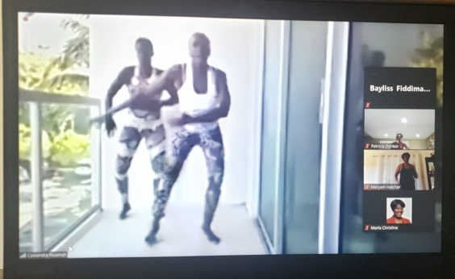
- Virtual DC Bar Candidates’ Forum (5.15.20): GWAC in collaboration with several other minority bar associations hosted this annual event to allow candidates running for various DC Bar board positions to discuss their vision, if elected to the DC Bar for their respective positions. This year, GWAC heard from two candidates running for the office of President-Elect, Charles Lemley and Chad Sarchio, who were both engaging and thoughtful.
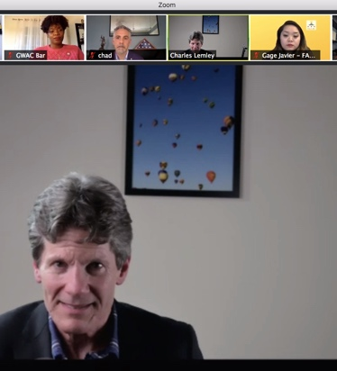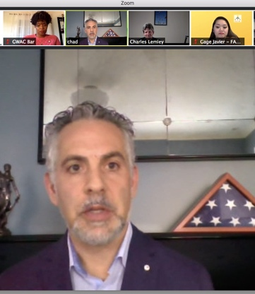

- GWAC Law Firm and Corporate Counsel Committee Virtual Happy Hour (5.19.20): GWAC’s Law Firm & Corporate Counsel Chair facilitated a virtual happy hour for members to gather and discuss issues that may have been plaguing them during COVID, as well as to share self-care tips to maintain a consistent routine and balance.
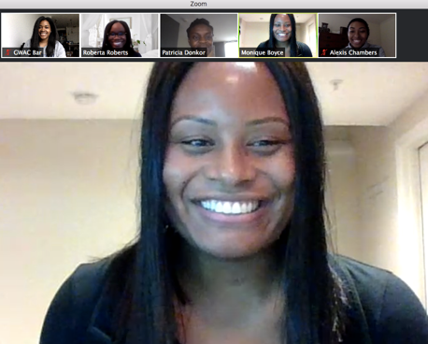

- Access to Reproductive Health Care: Being a Woman of Color During COVID-19 (5.21.20): GWAC co-sponsored this webinar to address access to reproductive rights during the coronavirus pandemic along with the Metropolitan Black Bar Association and Law for Black Lives DC.

- GWAC Women's Equity Series: Women of Color and COVID-19 (5.28.20): This virtual event featured expert Jamille Fields Allsbrook, Director of the Women's Initiative at the Center for American Progress. She shared many startling statistics surrounding the disparities that COVID-19 has had on women of color across the country and provided ways to support and advocate for those who are most impacted.

June 2020

- Annual GWAC Installation Ceremony (6.29.20): GWAC hosted a virtual installation ceremony to swear in its 2020-2021 officers. Chief Judge Anna Blackburne-Rigsby administered the oath.

- Virtual Toast to the Class of 2020 (6.30.20): To close out their law school journeys, GWAC hosted a virtual toast to celebrate and recognize GWAC members who graduated in 2020. Small tokens of celebration were also sent to GWAC’s graduating members.

July 2020

- Where are the Black Women Lawyers in Leadership Roles (7.16.20): GWAC and the Women’s Bar Association of DC hosted a panel discussion featuring the Honorable Chief Judge Anita Josey-Herring of the DC Superior Court, Hope Goins, Staff Director of the House Committee on Homeland Security, Fatima Goss-Graves, President & CEO of the National Woman’s Law Center, Sylvia F. James, Director of Diversity and Inclusion at Winston & Strawn, LLP, and Sandra Shaw, Vice President of Legal Affairs and Privacy Officer at BridgeStreet Global Hospitality. This event was moderated by Yolanda Hawkins-Bautista, Associate General Counsel of Freddie Mac. The esteemed panelists discussed how they overcame discriminatory obstacles in the legal profession in order to attain their current positions.

August 2020

- GWAC Annual Board Retreat (8.8.20): This retreat was a great opportunity for the GWAC board members to meet and get to know each other better while also collaboratively brainstorming programming ideas for the bar year.

- GWAC General Body Retreat (8.22.20): GWAC members gathered for its annual general body retreat. Here, members had the opportunity to meet one another virtually and participate in various icebreakers in small breakout groups and engaged in program brainstorming for the bar year.

- Legal Observer Training (8.26.20): As the number of marches began to increase over the summer following the killings on unarmed African Americans by police officers, GWAC, along with co-sponsoring organizations the National Bar Association’s Young Lawyers Division and the Washington Bar Association Young Lawyers Division, hosted a legal observer training facilitated by Law for Black Lives. Participants learned the basics about volunteering as a legal observer.

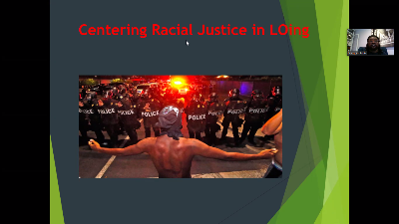

September 2020

- A Values Based Approach to a Balanced Life (9.23.20): GWAC hosted a financial wellness program facilitated by financial coach and consultant Jessica Medina, Esq. This event focused on what participants placed the greatest value on in their lives and creating financial plans that aligned with those values. Key takeaways included identifying your wants, needs, and “shoulds,” and crafting your financial plan such that a set portion of your income went to these three areas.

October 2020

- Cannabis-Black Ownership, Green Economy (10.16.20): GWAC partnered with the Catalyst Network Foundation and hosted a networking event, panel discussion and after work mixer to discuss Cannabis ownership in the Black community. Panelists included Al Harrington, Former NBA Player and Founder + CEO of Viola Brands, Rodney Thomas, Co-Owner of Viola Maryland, Linda Mercado Greene, Founder + Owner + Board Chair of Anacostia Organics, and Roy “Chip” Ellis, Chairman + Founder of Hemp Commodity Industries and Ellis Enterprises LLC.

- A Meeting of the Minds: Position of Power II (10.22.20): This event was held in collaboration with the Catalyst Network and several local bar associations. It focused on successful entrepreneurship within the African-American community and building wealth.
- John Lewis Good Trouble Voter Awareness March and Votercade to the Poll (10.27.20): This event was in collaboration with the Washington Bar Association and several other organizations. It took place in Ward 8 on October 27, 2020: the first day of early voting in the District of Columbia. People gathered, marched and participated from their vehicles in what was described as a “motor-cade.” A violinist performed two songs in honor of Elijah McClain. Those who could, knelt in remembrance of George Floyd.

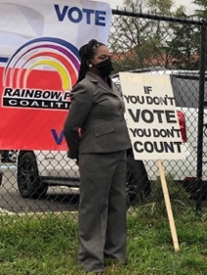
- A Virtual Screening of “The Judge” (10.29.20): GWAC, the Hispanic Bar Association of DC, and the South Asian Bar Association of DC hosted a virtual screening of the film The Judge, which centered on the first woman judge in Palestine’s religious courts.

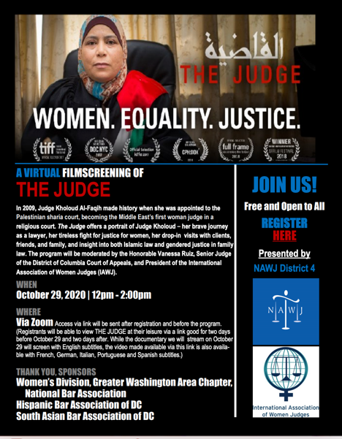

- Post-Election Scenario Planning (10.29.20): GWAC, Mothers Outreach Network, JMG Productions: Listen to Our Voices, Fair Budget Coalition, League of Women Voters DC, and NCOC gathered to discuss possible scenarios of the 2020 election and how to prepare local residents of the District for worst-case scenarios.

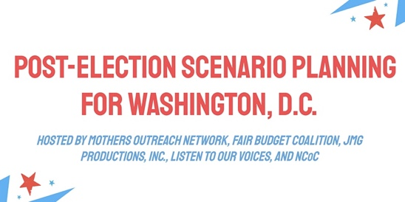

November 2020
- Chat and Chew (11.7.2020): GWAC hosted a Chat and Chew in order to give members a safe space to discuss the 2020 election results, which was formally being announced during the event.
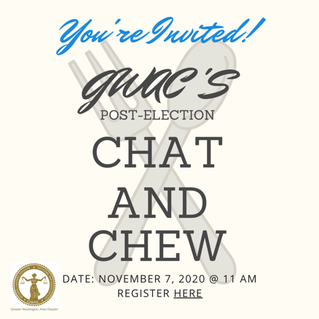

- A Conversation with the Judiciary: Re-imagining Diversity in Local and Federal Courts (11.12.2020): This was an engaging discussion with judges from the DC and Federal judiciary on diversity and inclusion efforts of federal and state courts, and the role of the judiciary in the political climate of the United States in 2020. We were joined by Chief Judge Anna Blackburne-Rigsby (District of Columbia Court of Appeals), Judge Emmet G. Sullivan (US District Court for the District of Columbia), Judge Carl E. Stewart (US Court of Appeals for the Fifth Circuit) and Judge Ann Claire Williams (Retired US Court of Appeals for the Seventh Circuit – currently Of Counsel, Jones Day).

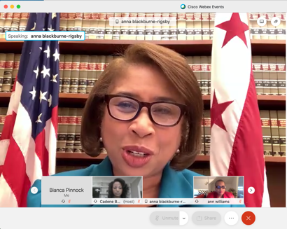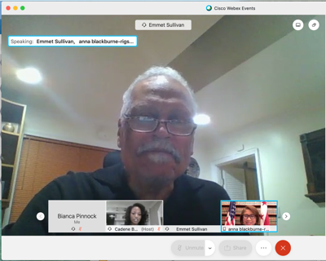
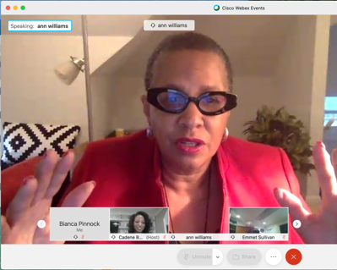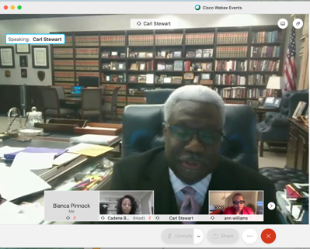
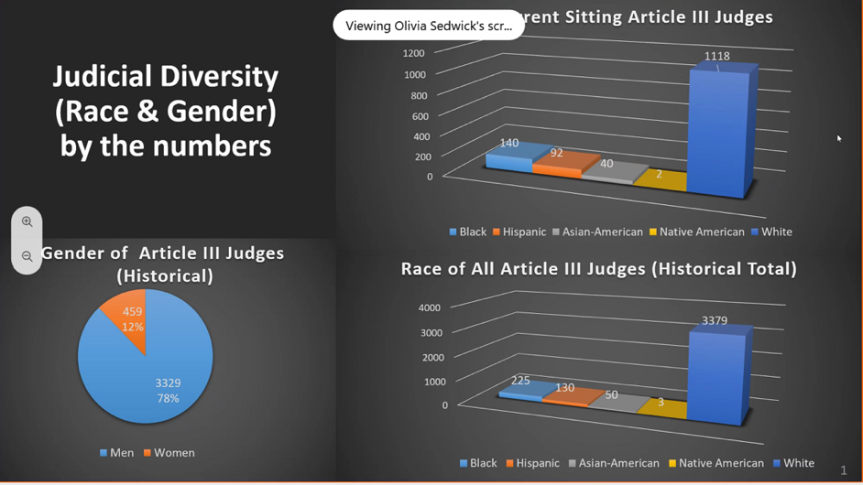

- Succeeding Despite: How to Overcome Racial and Gender Bias in the Legal Profession (11.18.20): GWAC hosted an honest discussion with an esteemed panel on how they have tackled racial and gender bias in their careers. They also discussed specific steps junior attorneys and all members of the profession can take to address it. The panelists included the Honorable Chief Judge Anna Blackburne-Rigsby of the DC Court of Appeals, Michelle Cober, Director of External Affairs, Verizon Sylvia F. James, Director of Diversity & Inclusion, Winston & Strawn LLP, and Dariely Rodriguez, Director of Economic Justice Project, Lawyers’ Committee for Civil Rights Under Law. The program was facilitated by Yolanda Hawkins-Bautista, Past President of the Women’s Bar Association of DC and Associate General Counsel, Freddie Mac.
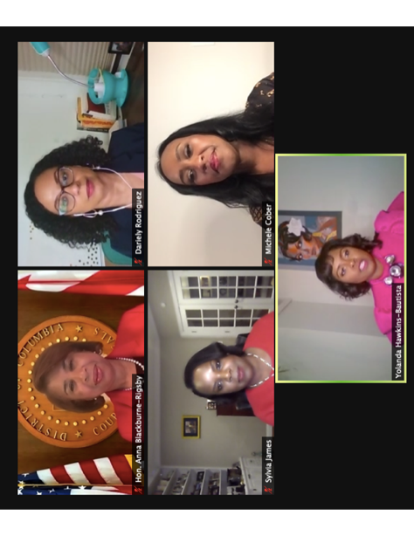

December 2020

- Dealing with Law School Debt, Presented by Financial Coach, Jessica Medina (12.8.20): Financial Coach, Jessica Medina, discussed how to manage law school debt in order to allow lawyers the ability to pursue their true passions no matter their salary.
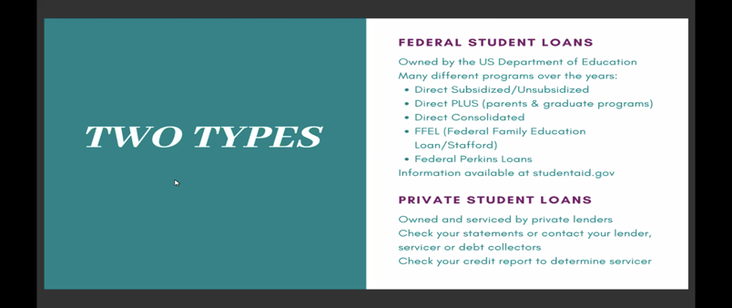
- 2020 Holiday Wreath Making Workshop (12. 13.20): GWAC and the GWAC Foundation, Inc. joined by Blooming Wood Creations, a Black woman lawyer-owned décor company that specializes in creating unique, handcrafted arrangements using various elements of wood, participated in a virtual holiday wreath making class.

- 2020 Barbara Whiting-Wright Networking and Awards Reception (12.17.20): GWAC presented the Trailblazer and Rising Star Awards in order to recognize distinguished and up-and-coming attorneys in the law firm, corporate, government and non-profit sectors. In 2020, the program was renamed in honor of GWAC’s founding President, the late Barbara E. Whiting-Wright who passed away in 2019.

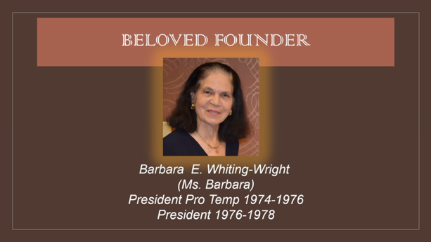
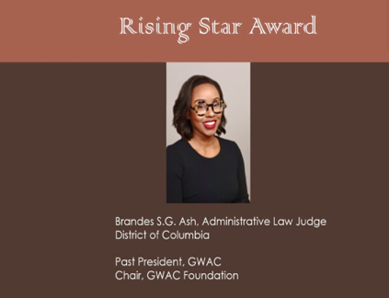
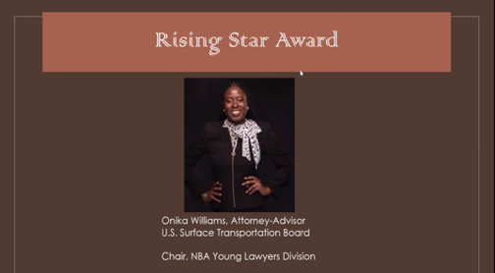
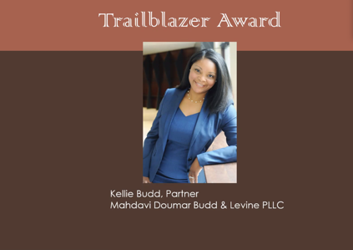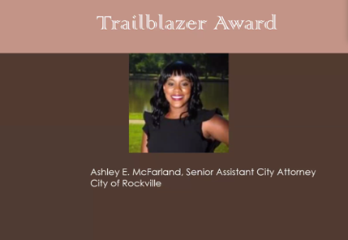
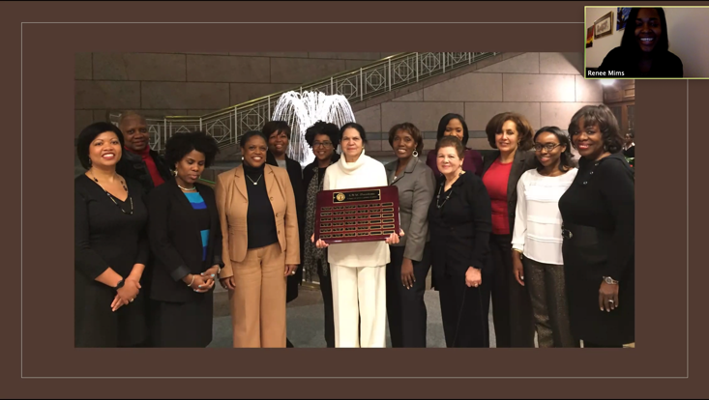

January 2021

- 18th Annual Career Fair – Resume Writing Workshop (1.23.21): GWAC and the Washington Bar Association held a resume writing and critique workshop in preparation for their annual career fair. Resumes were reviewed and critiqued by lawyers and judges in the DC legal community.

- Legal Writing Workshop with Professor Noah Messing (1.27.21): GWAC's Employment and Professional Development Committee hosted Yale University's Professor Noah Messing for our Legal Writing Workshop for an engaging and enlightening evening of fine-tuning our legal writing skills.

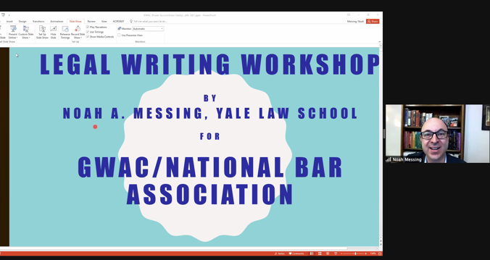
- Disrupting the Status Quo – How Are DEI Strategies Across Businesses and Law Firms Working: (1.28.21): GWAC, the Women’s Bar Association of DC, and the Washington Council of Lawyers hosted an impactful event centered on discussing Diversity, Equity and Inclusion issues across businesses and law firms.

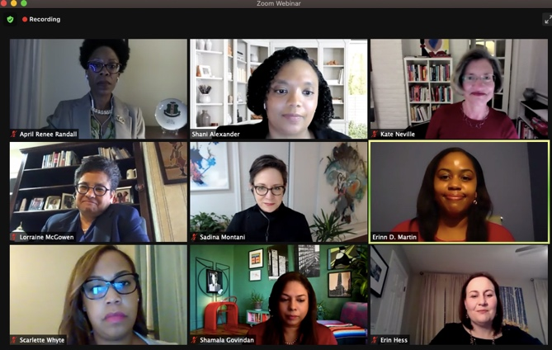
February 2021

- 18th Annual Career Fair – Interviewing Workshop (2.6.21): GWAC and the Washington Bar Association held an interviewing workshop in preparation for their annual career fair. Students heard from a local law firm diversity and inclusion officer (former recruiter), a magistrate judge, an administrative law judge, and a district attorney.

- Charlotte E. Ray Award Ceremony (2.18.21): This year, the 33rd annual Charlotte E. Ray Award Ceremony honored Professor Angela J. Davis, distinguished professor of law at American University, Washington College of Law. Professor Davis is an expert in criminal law and procedure, prosecutorial power and racism in the criminal justice system and is an exemplary role model and trusted mentor to younger attorneys and is an important contributor to the Washington, D.C. and national legal community.

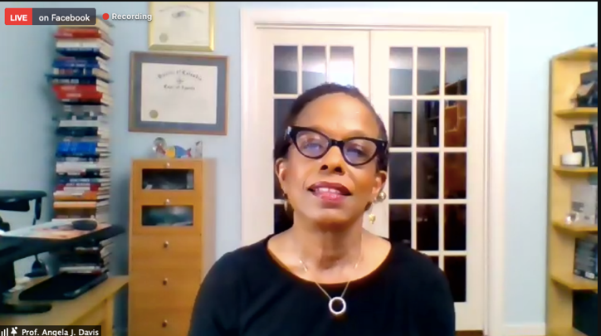

- We Keep Us Safe: Policing as a Reproductive Justice Issue (2.25.21): GWAC, American University Washington College of Law’s If/When/How Chapter and the Women and the Law Program invited and hosted an esteemed panel of experts to discuss how reproductive justice and abolitionist legal frameworks can foster a better future for Black people.

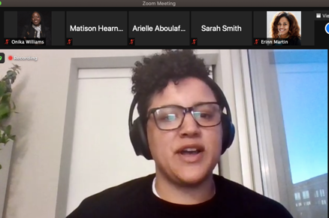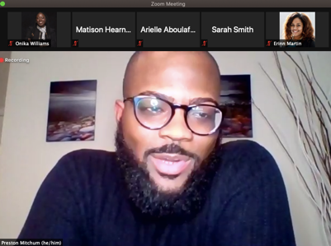

- A Legacy of Service: A Fireside Chat with Historically Black Bar Association Leaders (2.25.21): The Bar Association of the District of Columbia invited GWAC to participate in an informal, but informative discussion about the history and role of Black Bar Associations in the legal profession, and the value of participation in the bar associations and legal organizations.
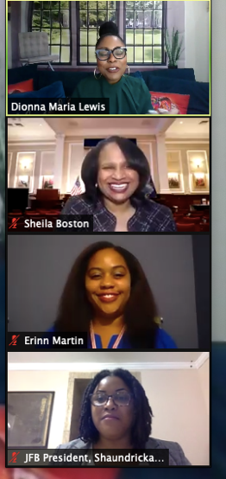

March 2021

- General Body Meeting and Vision Board Party (3.9.21): GWAC hosted its quarterly general body to recap the bar year so far and to share upcoming events. Following the meeting, GWAC hosted its annual vision board party for members to create physical or virtual vision boards for the year. Members set intentions for the rest of the year and fellowshipped during the event.

- Grocery Delivery to Seniors in Washington D.C. (3.20.21): GWAC and We Are Family Senior Outreach Network collaborated to delivery groceries to senior citizens during the COVID-19 pandemic.

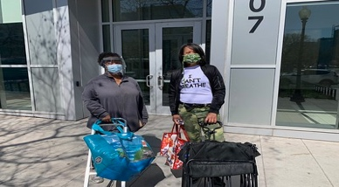
- The Eighteenth Annual Career Fair (3.20.21): GWAC and the Washington Bar Association held their annual career fair after the original date for the fair was postponed.
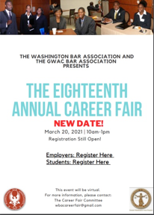
- Diversity Leads: Promoting Women and African Americans (as Judges and Clerks) in the Federal Judiciary (3.24.21) GWAC Partnered with the ABA Section of Litigation – Minority Trial Lawyer and Women Advocate Committees and the Judicial Intern Opportunity Program to have a panel discussion on the lack of women and African Americans as both judges and law clerks in the federal judiciary. Members of the panel included Judge Bernice Bouie Donald, United States Court of Appeals for the Sixth Circuit; Judge Carlton Reeves, United States District Court for the Southern District of Mississippi; Judge Vanessa Gilmore, United States District Court for the Southern District of Texas; Judge Sharon Coleman, United States District Court for the Northern District of Illinois; Prince Chambliss, the first African American Law Clerk to a United States District Judge in the State of Alabama; and Shanisha Y. Smith, former law clerk to the Honorable George C. Hanks, Jr. of the United States District Court for the Southern District of Texas. GWAC member LaFonda Willis moderated this event.

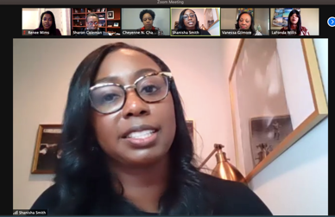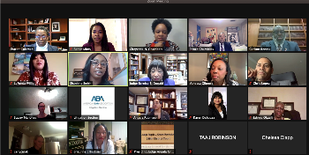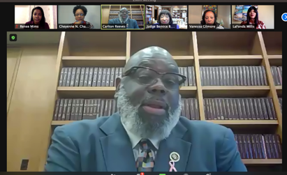

- The Hill: A Candid Conversation about Getting Jobs and Working on Capitol Hill (3.25.21): Legislative Affairs Chair, Ruth El, moderated a panel of esteemed Capitol Hill professionals. Attendees received a wealth of information on how to secure employment on the Hill and excel while there. Panelists included Keenan Austin Reed, VP at Alpine Group Partners; Halimah Najieb-Locke, Senior Adviser to the Deputy Secretary of Defense; Charlyn Stanberry, former Chief of Staff at U.S. House of Representatives; Meagan Sunn, Tech, Telecom, and Judiciary Counsel at United States Senate; and Brittany Hughes, U.S. Legislative and Regulatory Supervising Associate at EY.

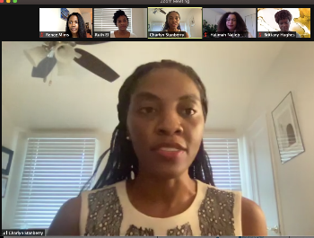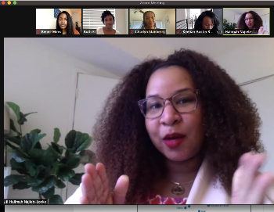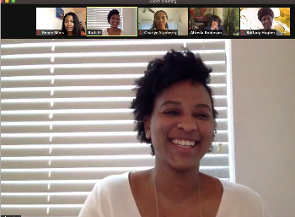
- The Government’s Role in Combating AAPI Hate (3.30.21): GWAC partnered with APABA-DC to discuss the role of the federal and state government with regard to efforts in combating hate crimes and acts of discrimination against the AAPI community. Panelists included Jessie K. Liu, Partner at Skadden, Arps, Slate, Meagher & Flom and Roy L. Austin, Jr., Vice President for Civil Rights & Deputy General Counsel at Facebook.
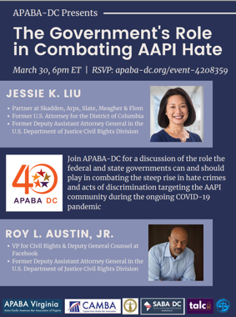
- GWAC Dinner Series featuring Kisha A. Brown (3.31.21): Periodically, GWAC hosts a private dinner for members only featuring someone in the legal community who can impart wisdom on GWAC members. For the month of March, GWAC hosted Kisha A. Brown, CEO and founder of Justis Connection, a referral business specifically highlighting Black attorneys.
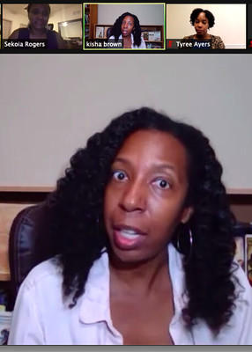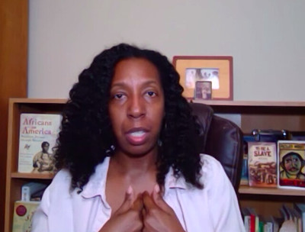
- Becoming a Judge (3.31.21): The Judicial Nomination Commission, American Constitution Society DC, GWAC, Hispanic Bar Association of the District of Columbia, National Bar Association, and the Women Lawyers Division collaborated to host a discussion for lawyers who aspire to be judges. The Judicial Nomination Commission discussed the judicial application, nomination, and appointment process for the District of Columbia Court of Appeals and the Superior Court of the District of Columbia. Panelists included The Honorable Emmet G. Sullivan, Judge, U.S. District Court for the District of Columbia; Addy R. Schmitt, Member and Litigation Vice Chair, Miller & Chevalier Chartered; and Benjamin F. Wilson, Chairman, Beveridge & Diamond PC. The event was moderated by Tracy B. Nutall, Executive Director, DC Judicial Nomination Commission.
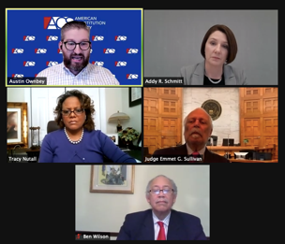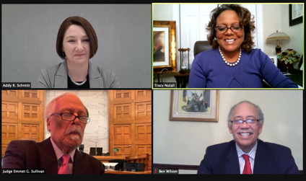

April 2021

- “In the Know” Trivia Night (4.1.21): GWAC Secretary, Ariel Woodard-Stephens, hosted a virtual trivia night, where GWAC members got together and took their best guesses at the topics of DC Legal History, Pop Culture and Mixology 101.
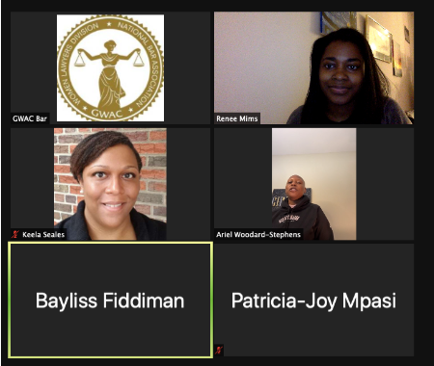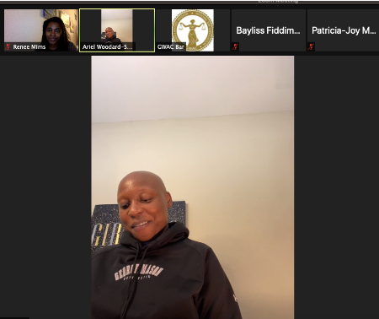
- Diverse Executives: Rising to the Top (4.14.21): GWAC served as a co-sponsor for this Washington Council of Lawyers program, which was moderated by GWAC member Henry Floyd. Attendees learned about the various career paths and challenges of the program's panelists, along with possible solutions for increasing representation.
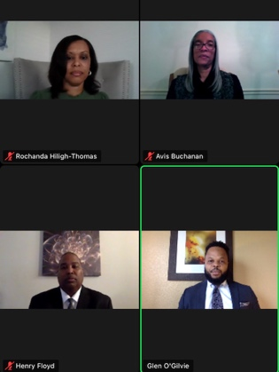

- FIRE For Lawyers (4.20.21): GWAC hosted financial planners Jessica Medina and Rho Thomas. The speakers discussed financial independence and management.

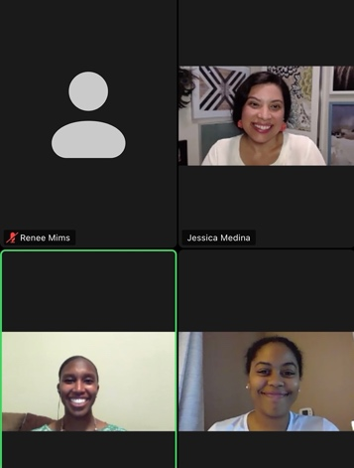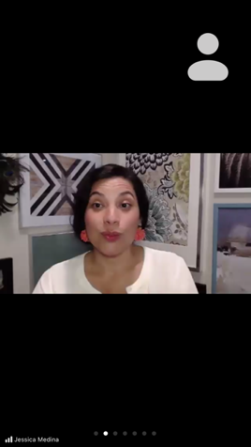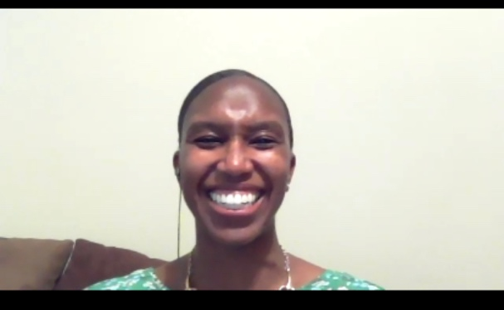

- Women in Blue: The Role Female Police Officers Play in Police Reform (4.23.21): GWAC co-sponsored the "Women in Blue" panel, where we heard from Black women about their journeys and perspectives being in law enforcement.
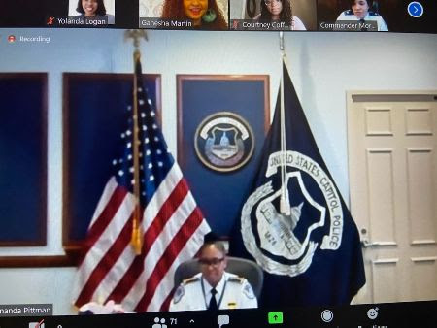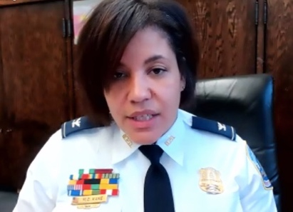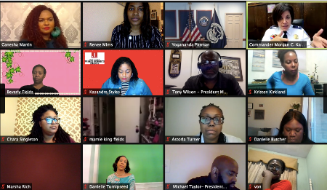

May 2021

- Spring 2021 Fitness Challenge (5.17.21 thru 5.23.21): GWAC members participated in a friendly competition to see which top three members could walk the most steps during a week. The winners received gift cards.

- GWAC Ends Hunger Games (5.1.21 thru 5.31.21): In support of the DC Bar’s Food from the Bar Campaign to raise money to help suffering from hunger, GWAC matched the first $500 received in donations. GWAC raised a total of $1,179 for the Campaign.

- John Lewis Voting Rights Motorcade (5.8.21): Members of GWAC joined together for a motorcade in honor and recognition of National John Lewis Voting Rights Advancement Action Day.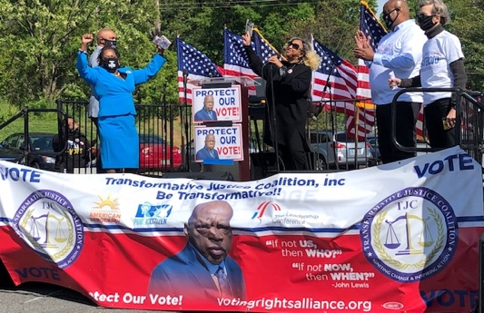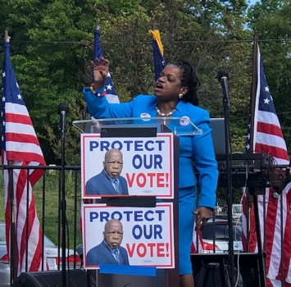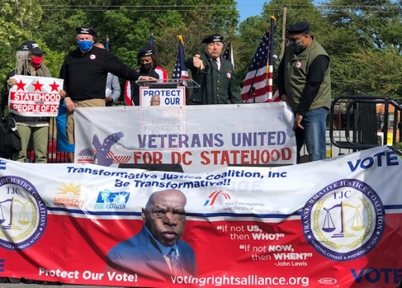

- The Effects of Mass Incarceration on Communities of Color in the Wake of COVID-19, ABA Panel (5.10.21): GWAC hosted a panel discussed on the current effects of mass incarceration on communities of color during the COVID-19 pandemic, the life of returning citizens, collateral issues they face, and how to deal with these issues in order to ensure the dignity, health, and safety of those returning citizens. Panelists included: Jarrett Adams – Attorney at Law, The Law Office of Jarrett Adams, PLLC; Izuo-Ere "Mimi" Digifa – Founder, FLOLANGO; Cohort 2 Fellow, Pivot Program, Georgetown University; and Professor Michael Pinard – Francis & Harriet Iglehart Professor of Law and Co-Director, Clinical Law Program, University of Maryland. The event was hosted by Melanie E. Bates (Moderator) – Principal Consultant, Melanie Bates Consulting.
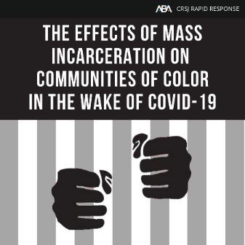

- Belly of the Beast Film Screening and Discussion (5.13.21). GWAC hosted a riveting screening and discussion of the film “Belly of the Beast,” which centered on illegal sterilizations of women in California prisons.
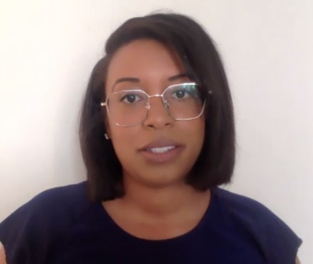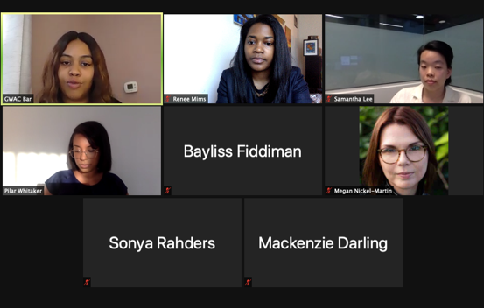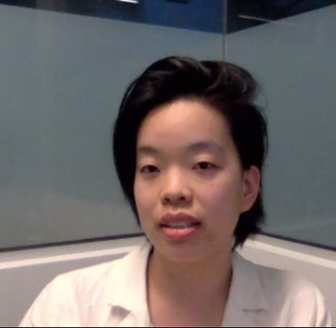

- Personal Branding and Style with Melanie Lippman (5.19.21): Melanie Lippmann taught GWAC members all about style, including how to develop a style that makes you feel powerful, and look put together, and how to use your wardrobe to showcase consistency, clarity, and confidence to yourself and those around you.
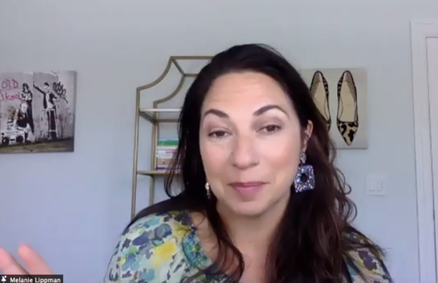
- GWAC Happy Hour Virtual Wine Tasting (5.20.21): GWAC hosted a virtual wine tasting to which several members attended and won prizes!
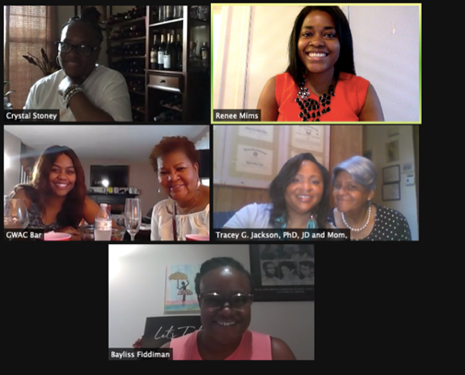
- Pathways to Senior Executive Service (5.20.20): GWAC co-sponsored this event which was spearhead by the South Asian Bar Association of DC. Attendees learned about the Senior Executive Service (SES), how to enter and navigate careers in federal agencies and achieve promotion therein, and the importance of diversity in the SES ranks.
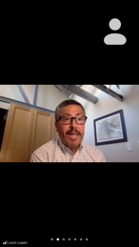
- GWAC Dinner Series Featuring Sade Dada (5.25.20): GWAC hosted a members only dinner featured guest speaker Sade Dada, Africa Public Policy, Access and Connectivity at Facebook.

- Virtual Toast to the Class of 2020 (6.3.20): To close out their law school journeys, GWAC hosted a virtual toast to celebrate and recognize GWAC members who graduated in 2021. Graduates in attendance also received gift cards.

